** ASBAT EXAMINATION BOARD**

**MIDTERM II EXAMINATION 2023**

**Age Group (5 – 6 years): TOP CLASS**

**Learning Area 4: Mathematical Concepts**

My name is ______________________________________________

**School: _________________________________________________________**

1. **Name the sets.**

A set of 3 moons

________________________

_________________________

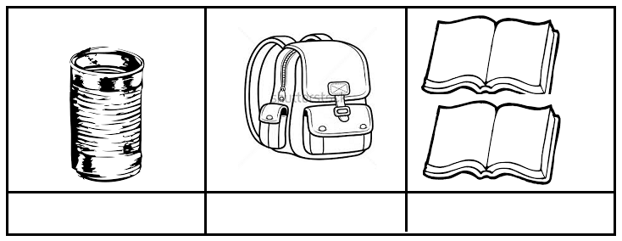

__________________________

____________________________

1. **Write the number before.**

____ 2 _____ 4 ____ 9

____ 5 ____ 3

1. **Fill in the missing letters.**

tr ___angle z ___g – zag st ___r

squ___re k___te r___ctangle

ov___l cir____le

1. **Match number word / name.**

1 nine

5 four

9 eight

4 five

8 one

1. **Shade for the number.**

|  |  |
| --- | --- |
| 5 = |  |
| 9 = |  |
| 8 = |  |
| 6 = |  |
| 0 = |  |
| 7 = |  |

1. **Add these pictures.**

+ = ______________

+ = ______________

+ = _____________

+ = _____________

+ = ______________

1. **Add these numbers.**

0 000

1 + 3 = 4 3 + 2 = _____

2 + 2 = ____ 5 + 1 = ______

1 + 0 = ____

1. **Draw balls for the number.**

3

10

8

7

**END**